

**Project Report**

**Artificial Intelligence**

**SMART TENDERING PLATFORM**

**Submitted To:**

Mam Sahar Waqar

**Submitted By:**

Asad Mughal 2018-CE-219

Saad Ali 2018-CE-228

## Introduction:

Smart Tendering Platform is a system that provides its users (mainly Consultants, Manufactures and Service providing companies) a best interface, where they can easily get tenders in which they are interested. This system **recommends** tenders to a user according to his **behavior** (clicks) and provided information (at signup). So, this system covers both content and collaborative base filtering to recommend tenders.

## Methods and Materials:

* **Data Set:** We have created our own dataset. We get tenders from [Public Procurement Regulatory Authority](http://ppra.org.pk/) Website through **Web Scraping**
* **Database:** We have used SQLite database to store our tenders
* **Machine Learning:** We have implemented K-modes algorithm, which is basically a clustering algorithm (unsupervised learning) because tenders are categorized without having a proper class
* User Interface: We rendered recommended tenders on a web page using python flask

## Procedure:

### The k-modes clustering algorithm is an extension of k-means clustering algorithm. The k-means algorithm is the most widely used center based partitional clustering algorithm. Huang extends the k-means clustering algorithm to k-modes clustering algorithm to group the categorical data.

So, what we did is, we made **30 clusters** of our dataset and save it in the array.

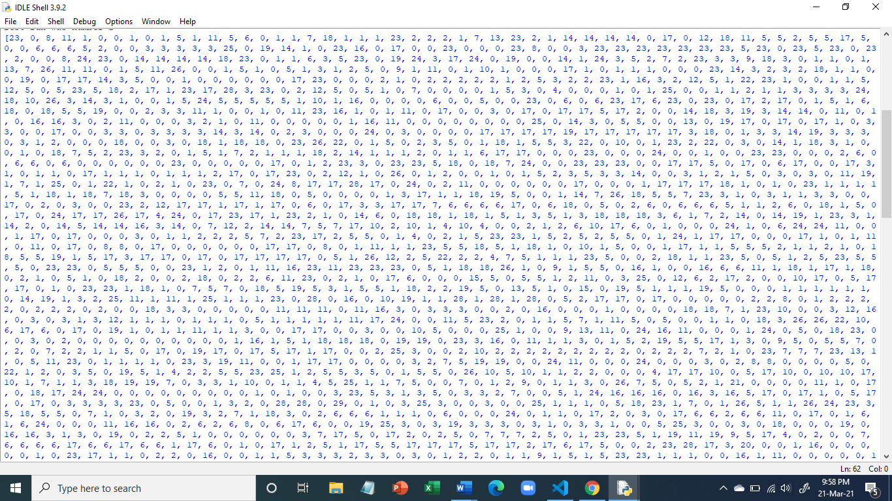

When user clicks tenders, we filter all the clusters from which that tender belongs. After that we again apply K-modes algorithm on the filtered tenders with user information, again clusters are formed. Finally, we recommend those clusters from which user information belongs. Question arises if a user clicks multiple tenders, multiple times. Then we prioritize the tenders according to the number of clicks and showing that cluster of tenders first, that received more clicks.